 |  | Tuya Edge Gateway (Enterprise) | Tuya Edge Gateway (Professional) | Tuya Edge Gateway (Lite) | Tuya Virtual Edge Gateway | Tuya  Commercial Zigbee Gateway | Tektelic LoRa Gateway
Cost |  | $XXX | $XXX | $XXX | $XXX/yr | $XXX | $XXX
Max Number of Devices |  | 1000 | 500 | 100 | 5000
Processor System |  |  |  |  | 可以不同项目共享  注意数据安全隔离 |  | ARM-based SoC
Memory |  |  |  |  |  |  | RAM: 512 MB DDR3 (typical)  Flash: 4 GB eMMC
Storage |  |  |  |  |  |  | Internal flash storage (eMMC)
Networking |  | 4G | 4G | 4G | - | 4G | 4G
 |  | WI-FI | WI-FI | WI-FI | - | WI-FI | -
 |  | Ethernet | Ethernet | Ethernet | - | Ethernet | Ethernet
Interface | Serial Port | 2x RS485 | 2x RS485 | 2x RS485 | - |  | -
 | Ethernet | 2x Ethernet Port | 2x Ethernet Port | 2x Ethernet Port | - |  | Ethernet
Work Environment | Operating Temperature | -35~75C | -35~75C | -35~75C | - |  | -0~40C
 | Operating Humidity | 5~95%RH | 5~95%RH | 5~95%RH | - |  | 5~95%RH
 | Storage Temperature | -40~85C | -40~85C | -40~85C
Protocol Supported |  | Modbus RTU/TCP | Modbus RTU/TCP | Modbus RTU/TCP | - | - | Modbus TCP
 |  | BACnet MSTP/TCP | BACnet MSTP/TCP | BACnet MSTP/TCP | - | - | BACnet TCP
 |  | MQTT | MQTT | MQTT | - | - | MQTT
 |  | - | - | - | - | Zigbee
Security | Hardware Encryption |  |  |  |  |  | Secure element for key storage (AES-128)
 | VPN Encryption |  |  |  |  |  | IPsec VPN  OpenVPN (depending on firmware/config)
Operating System |  |  |  |  |  |  | Embedded Linux-based OS
Certification |  |  |  |  |  |  | UL / CSA / EN / IEC 62368-1  FCC: 15.247, 15.109, 15.209 ISED: RSS - 247, RSS - Gen CE: RED 2014/53/EU  IMDA
Warranty

add water meter, lifespan based on no of times to upload the data, spec (Lora, zigbee) DN25/15/?and price.
power meter specs and price (single phase, three phase, below 120A, below 250A, below 300A) Zigbee bituo 3 phase one need to show all data

Hardware/Device Requirements

Local Data Storage
The Edge Gateway hardware should have storage capacity to hold a minimum of 1 month of data for all measuring data based on required acquisition rate. The stored data should not be affected by any loss of power supply, network connectivity
Data Synchronisation
When connectivity is restored, the platform must automatically synchronise the locally stored data with the central system.

Data Points
Power Meter: kwh, voltage, A, frequency, peak load, Kva，Kvar, power factor
Water Meter: meter reading, battery health status, etc
Gas Meter: meter reading, battery alert, etc
Utilities measuring hardware should have storage capacity to hold a minimum of 1 month of data for all measuring data based on required acquisition rate. The stored data should not be affected by any loss of power supply, network connectivity or server problem. The data should be uploaded and synchronized automatically upon restoration of power and the Platform. Edge gateway will have 1 month data storage

Check what’s the data displaying period on Netzero utility platform, knowing that tuya cloud can only store 7days data, should be 36 months of data on netzero based on HDB tender requirement, 3 decimal places
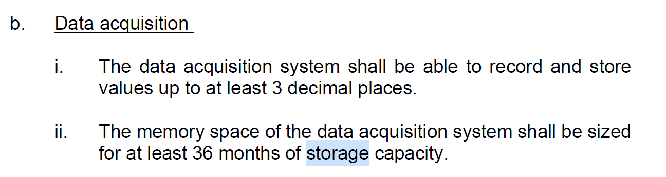

Supported Communication Protocols
The platform shall support multiple communication protocols to ensure compatibility with various utility metering devices.
Supported protocols include:
lMQTT (Through Edge gateway)
lZigbee - Tuya
lWifi - Tuya
lLora (MQTT) (Through Edge gateway)
lModbus to MQTT (Through Edge gateway)
lBACnet

CAG BILL Contract, kitchen (power and water), API…
Edgegateway onboarding device one time…改...
Device health status check (Device Status/online/offline report, Data transmission status report)
The Platform shall be able to monitor the hardware health status (i.e. gateway, Utilities measuring hardware, etc) and detect the following:
(a) Communication and connectivity failure (once data are not received/transmitted)
(b) Hardware malfunctioning (through the readings received, e.g stagnant readings over a long period), but stagnant could be caused by no usage, not faulty also.
Data transmission health check: if device offline, or device online, but data jam such as didn't receive data over a period of time, or receive same set of data continuously

Virtual Meter
The platform shall support the creation of Virtual Meters.
Virtual meters allow calculated data values based on multiple physical meters or logical aggregation.
Example Use Cases
lTotal Energy Consumption per Floor: sum of all the meters in the rooms
lTotal Energy Consumption per Building: sum of all the meters in the rooms
lEnergy Consumption in Common Areas: Total circuit meter - sum of all the meters in the rooms

Appliance Type Tagging
The system shall support Appliance Type Tagging, allowing devices to be categorized according to their usage type.
Example categories include:
lLighting
lPlug Load
lAir Conditioning
lOthers
Allow users to self create tagging catagory
The platform shall provide analytics to break down and analyse energy consumption by appliance category.
Example analysis includes:
lLighting energy consumption
lHVAC energy consumption
This functionality enables users to identify which systems or equipment types contribute the most to overall energy consumption and helps support targeted energy optimization and conservation strategies.

Services | Cost | Unit | Conditions
Basic Utilities Saas | $10,000 | Year | Up to 5000 Devices  What is the limitation
BMS Integration |  | One Time
API Integration |  | One Time
SMS |  | Monthly
Customisation |  | Mandays

S/N | Section | Sub-Section | Function | Supporting Details | Samples
0 | Login |  | - Support multi-factor authentication (MFA) for system administrators and privileged users.  - Password  - OTP via Email/SMS  - Support integration with Authority's Azure Active Directory using SAML authentication protocols.  [Original Temasek Poly Tender Requirement] | Password Policy  - Enforce minimum password length of 12 characters made up of at least 2 out of the following 4 types: Uppercase, Lowercase, Digits and Special characters.  - Enforce password change once every 12 months or less.  - Prohibit Password Reuse for a minimum of 3 generations.  - Ensure passwords are not displayed in clear.  - Transmit only cryptographically protected passwords (e.g. encryption of passwords at application layer before transmitting over a secure channel)  - Store passwords in a form that is resistant to offline attacks.  - Enforce password change upon first login.  - Prohibit passwords from being the same as the account ID or user ID.  - Limit consecutive failed authentication attempts to 10 times or less; and  - Protect the system against dictionary and brute-force attacks. | Upon Signing based on the price quoted,  Provide Mock Up for VG to confirm before development  [Add another column for Tuya to provide Price]
1 | Overview | Portfolio  [global View]  Vector -> STL Site A Site B Site C CAG Site A Site B Site C  STL-> Site A Site B Site C  owner -> project A B C | - User can view all assets under the same organisation via a map or table view.  - Global Performance metric for the following which can be filtered by Today, MTD and YTD timeframe:  - Electricity  - Water  - Gas  - Carbon  - Cost  The user can use the search bar or various filter such as the country, operational status, facilities type to view the desired assets on the map view.  Hovering on the asset will show the name and location of the assets.  Clicking on the asset will provide details of the asset, i.e. Site Information – Name, Address, Facility Type, Total Site GFA, Key Performance metrics including the cost in which can be filtered by Today, MTD and YTD, Active Alarms for that particular asset. The user can click on the “Go to Site” button to have more details of the asset.  Performance Ranking of the sites are available and can be filtered by Facilities Type, Operational Status, performance metric or the different available timeframe.  [New Requirement] |  | 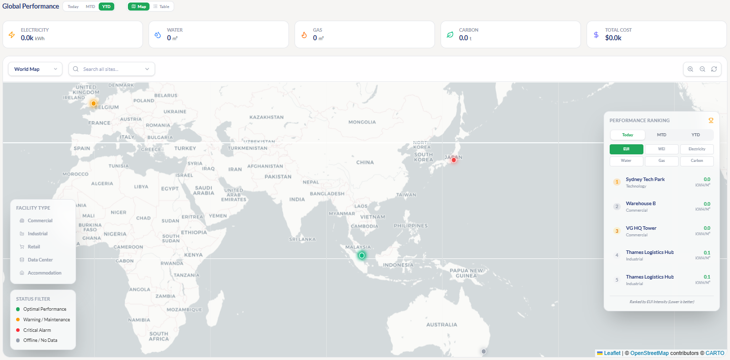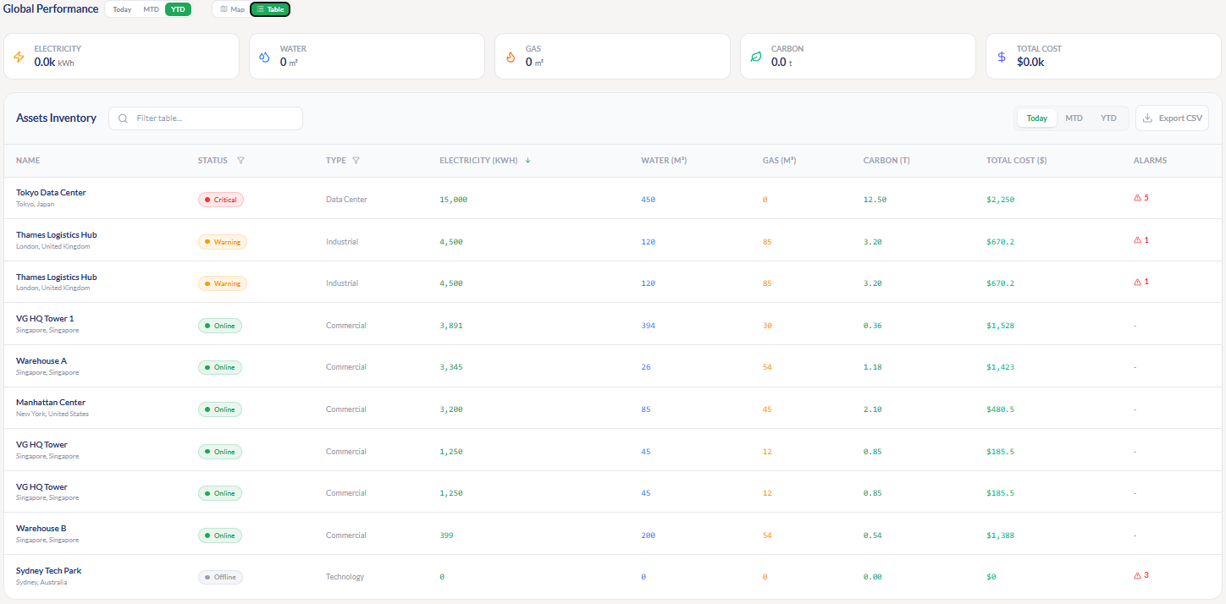
 |  | Dashboard  [project View] | Able to navigate projects within the organization  Device Statistic - To view the total devices onboarded and the status of the devices.  Fault and Alarm Statistic - To view active and resolved fault / alarms.  Real-time and historical dashboards which can be filtered by day, week, month, calendar year, financial year, or custom period showing utility data across hierarchy levels or Asset tags which consists of:  - Bar Chart  - Line Chart  - Heatmap  include Project description, Address, Total size (e.g., GFA), property type  [Original Temasek Poly Tender Requirement] |  | 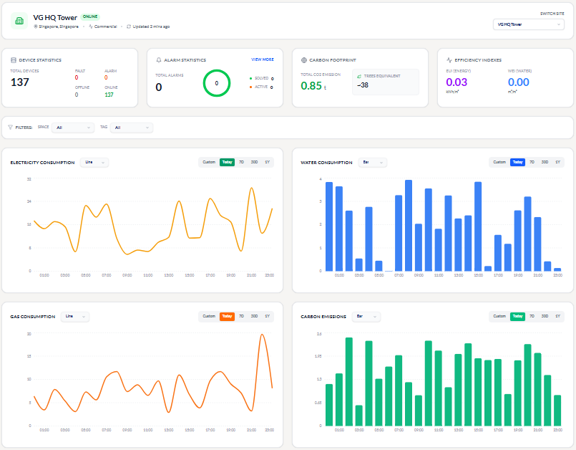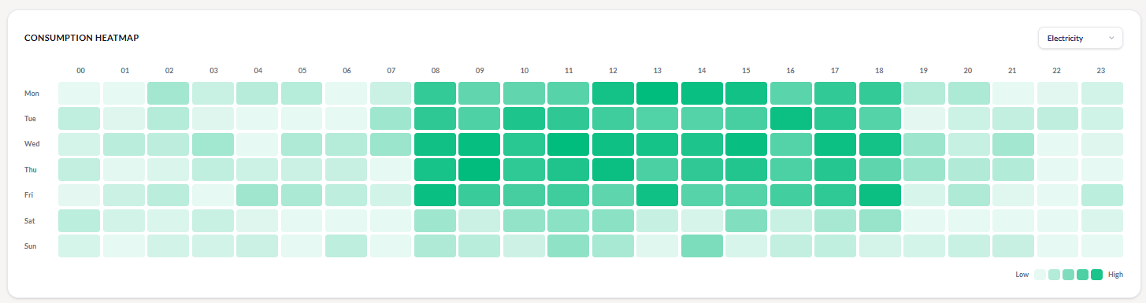
2 | Utilities | Electricity Management  [Project to Block to Room to Device View, no need map view] | Monitor electricity consumption and power parameters from device level up to room, floor, block, project, and portfolio level.  Support real-time current-month view, historical daily/monthly/yearly/custom analysis. For Kwh, A, V, as key icon for client to click to view those metric in history  Support live existing parameters of all the metric for this meter, such as V, A, KW, Kvar, Kva,  Pie Chart for the Distribution according to tags.  [pie chart and cost analysis will move to analysis tab, due to difficult to show pie chart if client click on device level information]  Electrical schematic or single-line diagrams only have this option at the relevant project level? block location? Or floor location?.  需要的地方/space画 不需要的地方不画 空着  这个功能 可以打开/关闭给特定用户。  [Original Temasek Poly Tender Requirement] | Schematic Diagram  Should enable filtering of consumption data by date time range. And allow different granular view of the diagram by campus, block and/or level.  [should schematic diagram only display live data? Live device data + consumption history (by date) And operating status such as online/offline?] if need consumption data over a period of range, should go to utilities tab  Display graphical indicators (e.g. colours, icons, etc) to the monitored Utilities measuring hardware for each detection and alert generated by the Platform. | 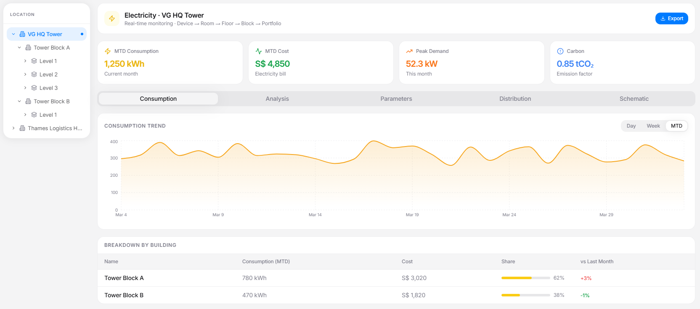  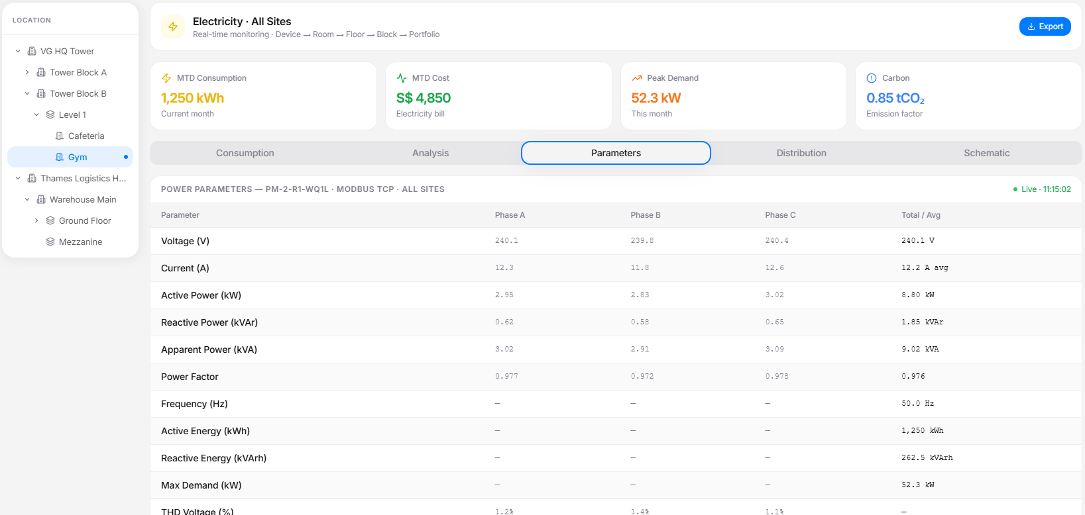  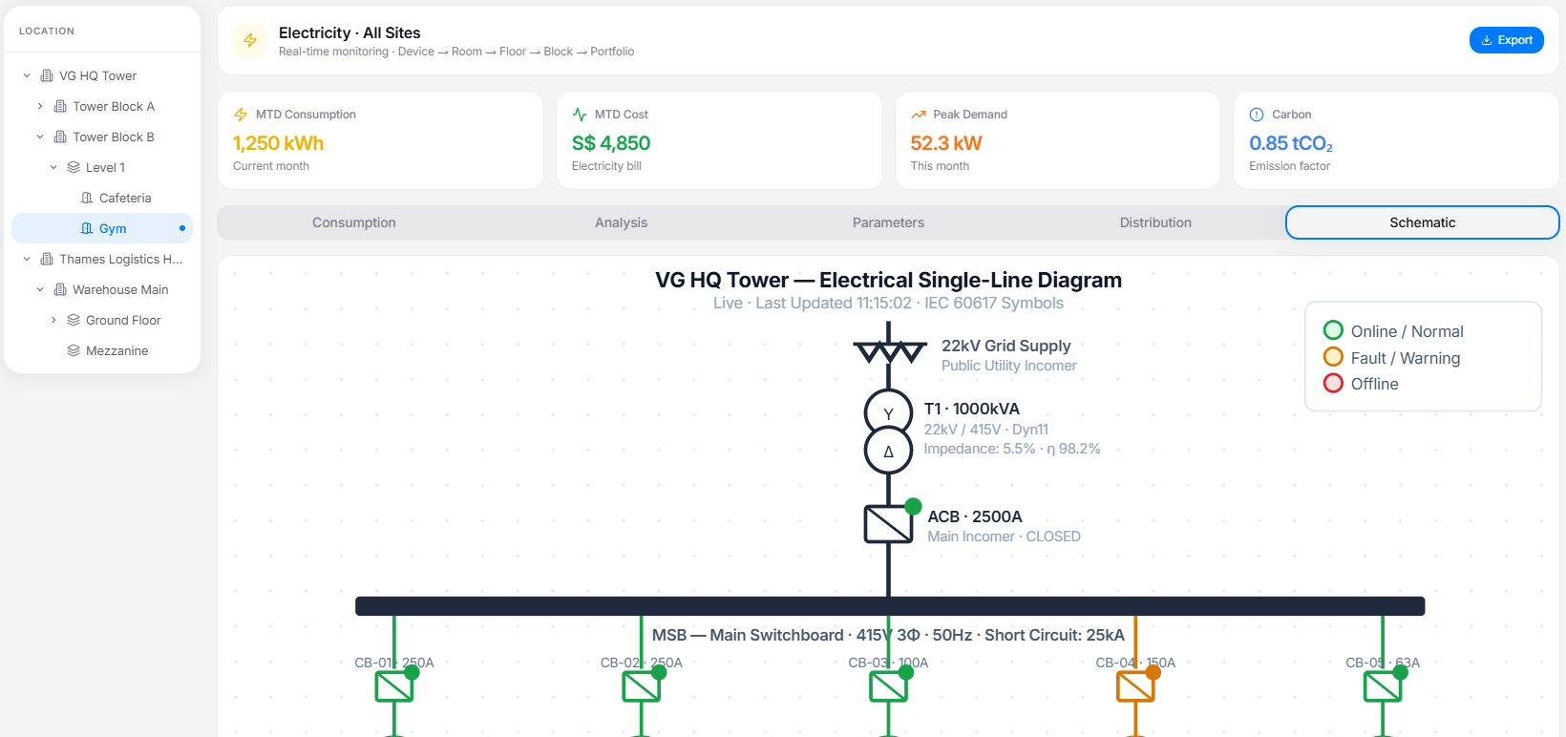
 |  | Water Management  [Project to Block to Room to Device View, no need map view] | Monitor water consumption from device level up to room, floor, block, project, and portfolio level.  Support real-time current-month view, historical daily/monthly/yearly/custom analysis. For water related key metric as key icon for client to click to view those metric in history  Support live existing parameters of all water related metric for this meter,  Pie Chart for the Distribution according to tags.  [pie chart and cost analysis will move to analysis tab, due to difficult to show pie chart if client click on device level information]  Water schematic or single-line diagrams.  water schematic only have this option at the relevant project level? block location? Or floor location?.  [Original Temasek Poly Tender Requirement] | Schematic Diagram  Should enable filtering of consumption data by date time range. And allow different granular view of the diagram by campus, block and/or level.  [should schematic diagram only display live data? And operating status such as online/offline?] if need consumption data over a period of range, should go to utilities tab  Display graphical indicators (e.g. colours, icons, etc) to the monitored Utilities measuring hardware for each detection and alert generated by the Platform.  Schematic 只show 我们有的数据就好 用水量 什么的 不需要加入别的 | 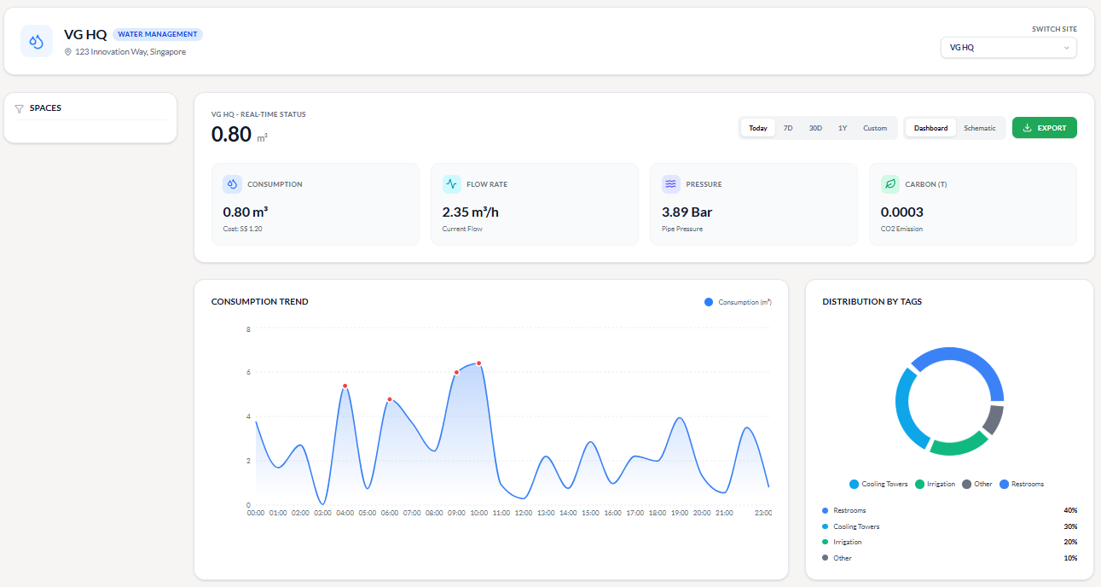  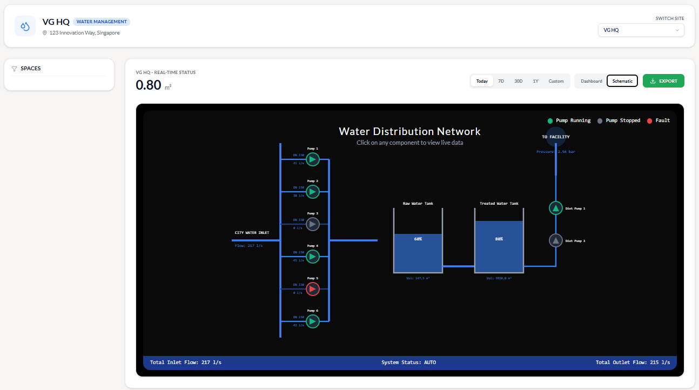
 |  | Gas Management  [Project to Block to Room to Device View, no need map view] | Monitor gas consumption from device level up to room, floor, block, project, and portfolio level.  Support real-time current-month view, historical daily/monthly/yearly/custom analysis. . For gas related key metric as key icon for client to click to view those metric in history  Support live existing parameters of all gas related metric for this meter,  Pie Chart for the Distribution according to tags. [pie chart and cost analysis will move to analysis tab, due to difficult to show pie chart if client click on device level information]  Gas schematic or single-line diagrams. only have this option at the relevant project level? block location? Or floor location?.  [New Requirement, propose to do it in next phase, Tuya can quote first] | Schematic Diagram  Should enable filtering of live consumption data by date time range. And allow different granular view of the diagram by campus, block and/or level.  [should schematic diagram only display live data? And operating status such as online/offline?] if need consumption data over a period of range, should go to utilities tab  Display graphical indicators (e.g. colours, icons, etc) to the monitored Utilities measuring hardware for each detection and alert generated by the Platform.  Least priority  Can manual off this part | 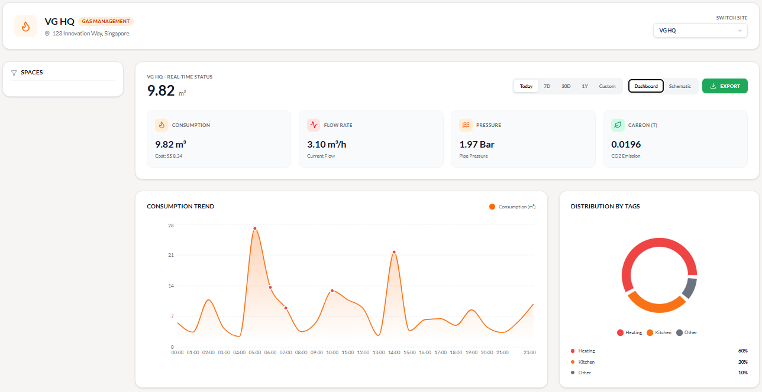  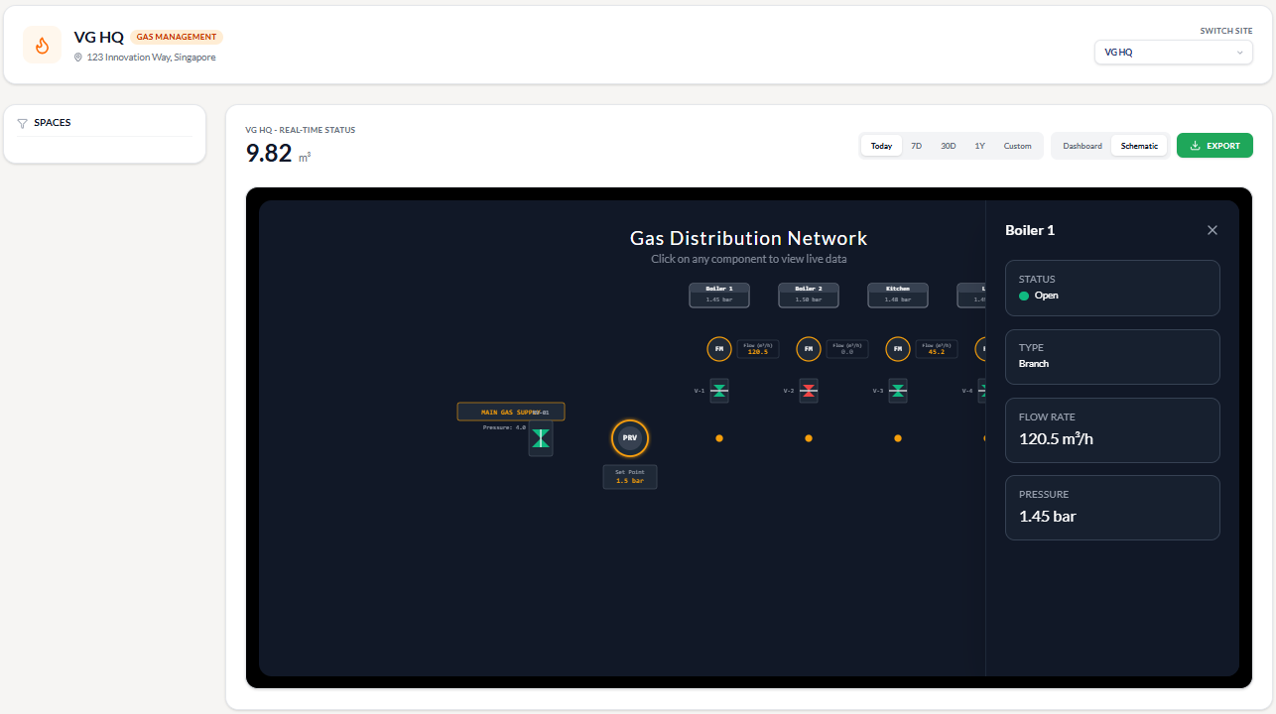
 |  | Historical utility Data Export | The platform must support exporting analytical data.  Users should be able to export data at:  lDevice level  lRoom level  lFloor level  Supported formats include:  lCSV  lExcel  [Original Temasek Poly Tender Requirement]
3 | Analysis  [new functions for 5000 package] | - AI Chatbot to ask any questions to analyse the data based on your requirement, also provide fixed template for users to generate report |  |  | 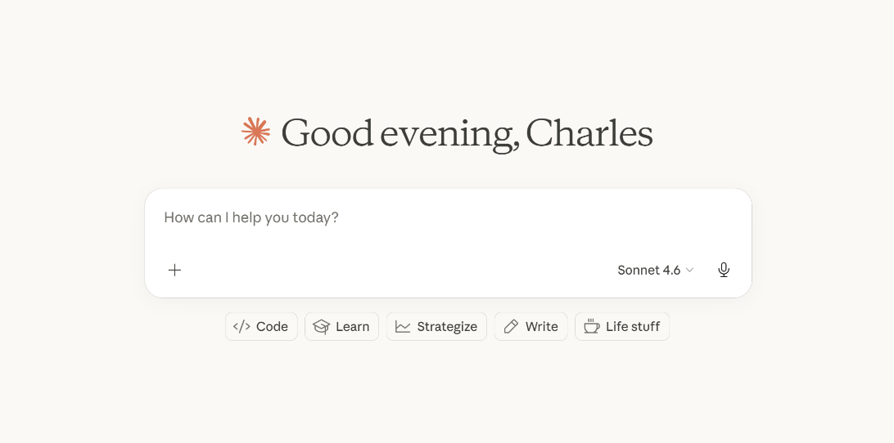  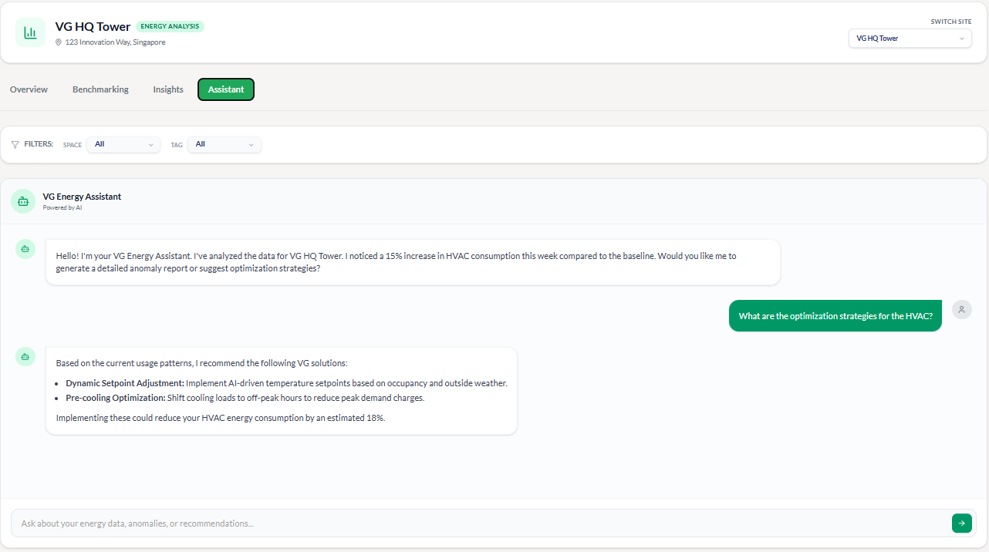
 |  | - Create 3 separate tabs for electricity, water, gas analysis differently [some of the analysis may not be relevant for water and gas, may need to research further on what analysis metrics are relevant for water, gas] | Provide a key highlight for each utility segment for management have a simple overview  Can switch between electricity, water, gas |  | May be a sample mock up page  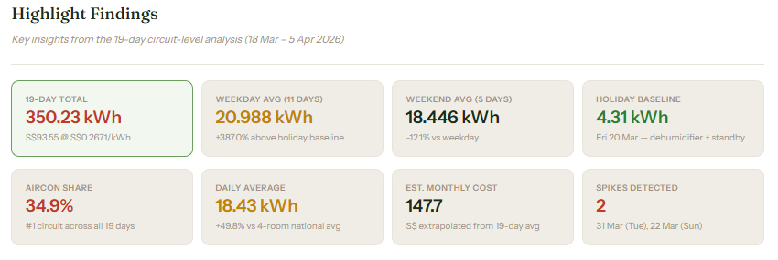
 |  | - Utility analytics based on SP bill as an overview analysis | Compare monthly differences, patterns across the year, vs national average, vs neighbour average,  Provide an overview of this property analysis as the big picture |  | 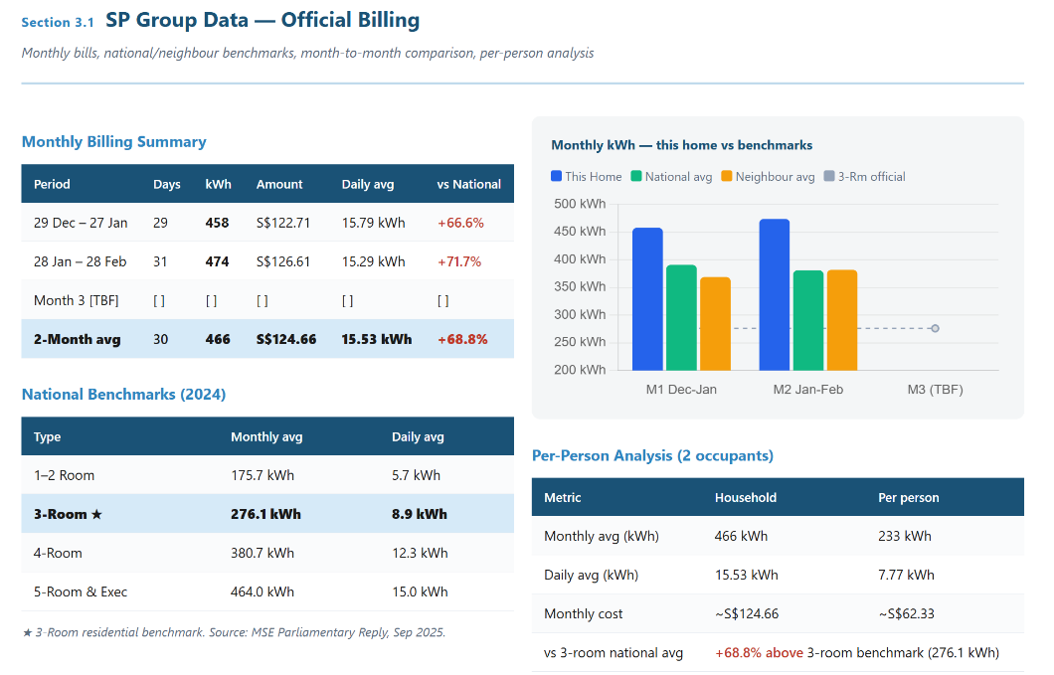
 |  | - AI Benchmarking for similar property type  - Insight generation.  - EUI/WEI calculation using GFA | If the property type is commercial office, or light industrial office, or dormitory, school, etc  compare the EUI/WEI with the similar bench march and calculate percentile ranking of your property vs the rest to get a sensing about your ranking | EUI = Energy Consumption / GFA  Unit: kWh / m²  The system must automatically compute EUI using historical energy consumption data.  WEI = Water Consumption / GFA  This metric helps evaluate water efficiency across buildings.  Maintain historical GFA records.  Example:  2024 GFA = 5000 m²  2025 GFA = 5200 m²  The system must apply the correct GFA value when calculating EUI or WEI based on the timestamp of the collected data.
 |  | - Operation profile analysis | Create different operational profile based on dates and classify energy consumption of those days under the same profile, eg  Office: working days 9am-6pm operational hour, weekend off.  Dormitory: 7am leave room, 6pm come back peak for 6 days, Sunday is off day should be highest energy consumption,  Different property operation should have different operational profile to match their energy consumption pattern. If not we are not comparing apple to apple |  | 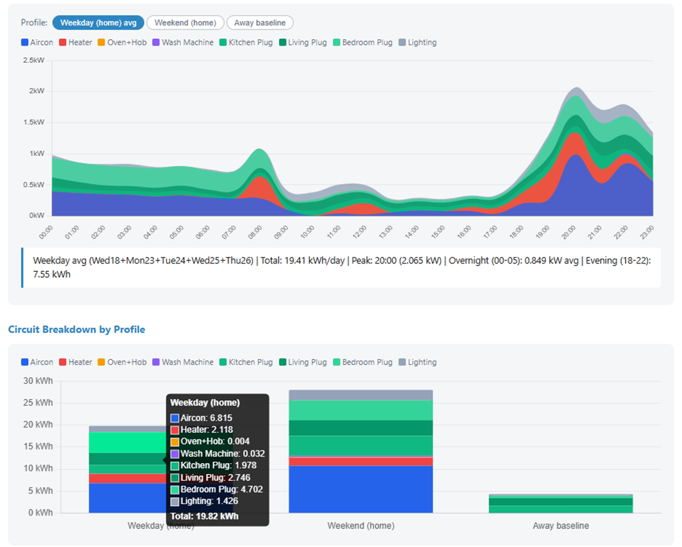
 |  | - Pie Chart for the Distribution according to tags. [pie chart and cost analysis will move to analysis tab, due to difficult to show pie chart if client click on device level information] | After knowing the profile of the energy consumption date, then we look at the distribution of energy consumption based on per circuit data. |  | 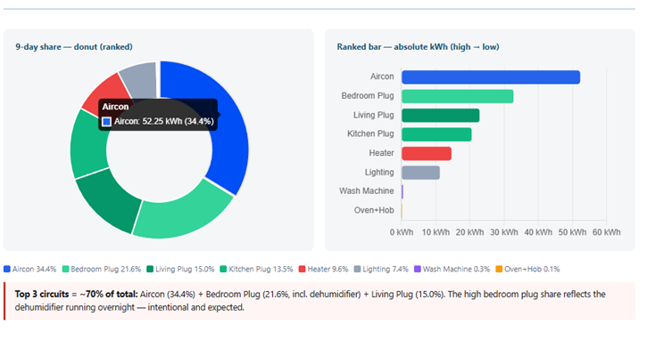
 |  | - Top consumer ranking, average-versus-actual comparison by room, floor, block, and project, appliance-type breakdown, abnormal consumption highlighting | Room/Floor/Block/Project Consumption ranking based on total/EUI/WEI/Per Pax/room type[classroom/auditoriam/ sport hall etc [average, red as top as outlier] Utility Ranking, pyramid style, just show the worst 10% or 100 rooms of the same type of the profile.  The platform should be able to generate a Utility Ranking Report.  The system shall identify:  lTop energy consumers based on per room, per floor, per block or per building  lTop water consumers based on per room, per floor, per block or per building  Ranking may be calculated based on:  lSpace  lUsage tag  人均消耗，需要有地方输入房间人数  based on per room level, generate top ranking abnormal energy consumption ranking based on monthly, with top room in red, slowly go down to orange, then a virtual line as the average, below average will be green  Type of facilities: office, dormitary, student accomodation, retails, factories etc |  | 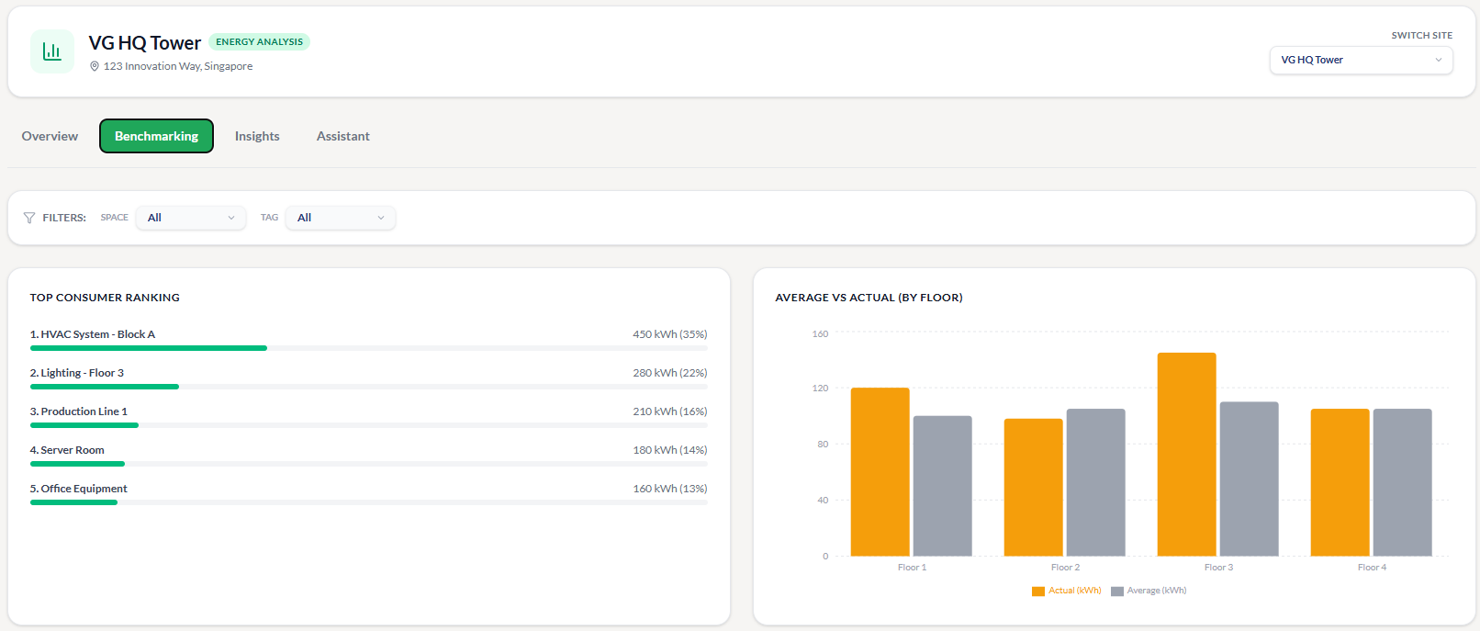  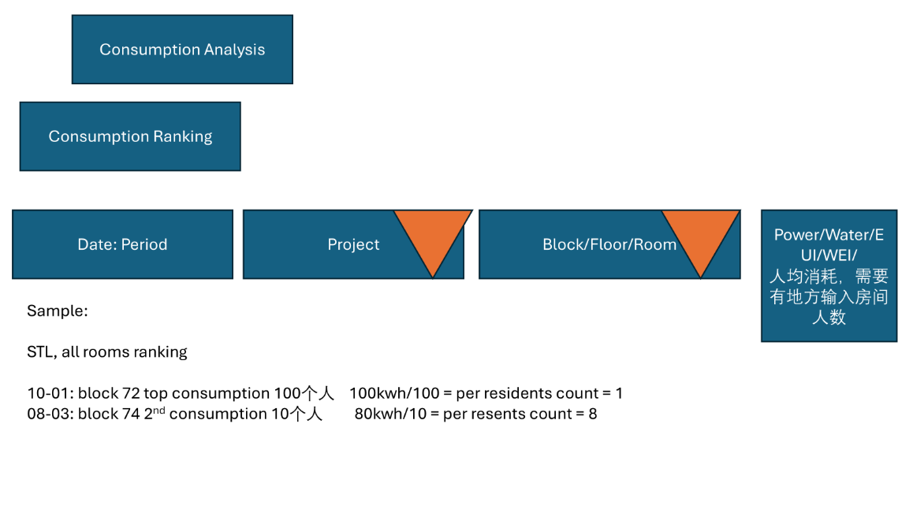
 |  | - Anomaly detection using rules or AI/ML methods.  Based on peak load for overloading, peak demand for appliance aging?  Any other metrics?  profile based on weekday office hour, weekday non office hour+weekend,  -- KWH for general consumption over operation hour, A for overload during weekday office hour down to circuit level, or weekend someone plug in unnessary power during that period, down to circuit level.  -power KW for peak demand, if peak demand increase over the time, then recommend client to change to more efficency hardware. | (Project Level, block level, Floor level, room level) Trend anormally, look into the cause of the anormally, by appliance type and room level cause [what's the cause of the anormally] report end of the day,  End of the day, when yst total energy consumption is anormal, AI will generate report to look at the cause of the spike in each circuit, then provide a detail analysis for the management to diagnosis the following day |  | 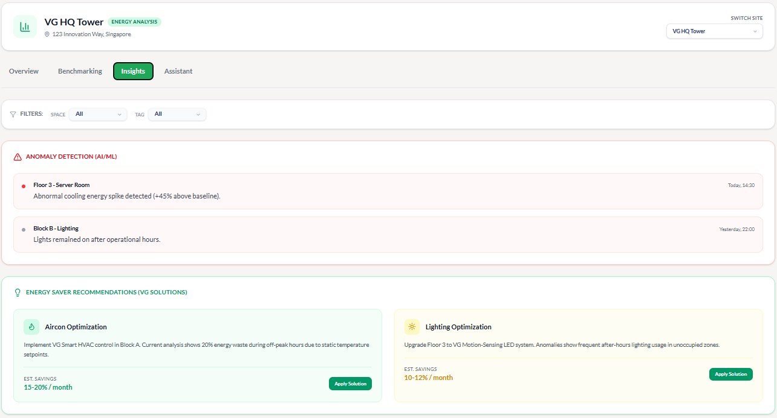  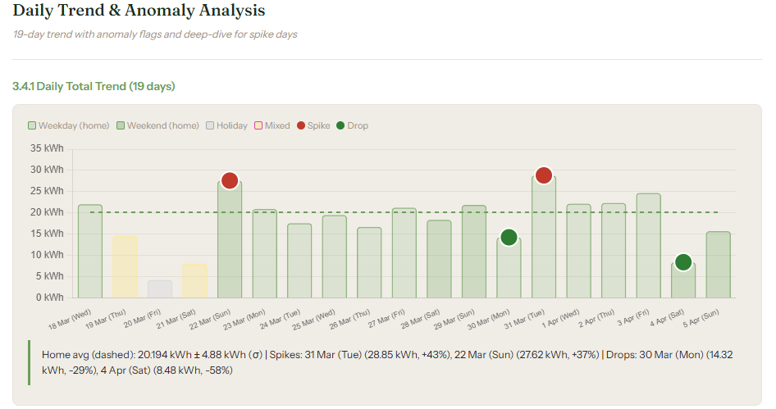  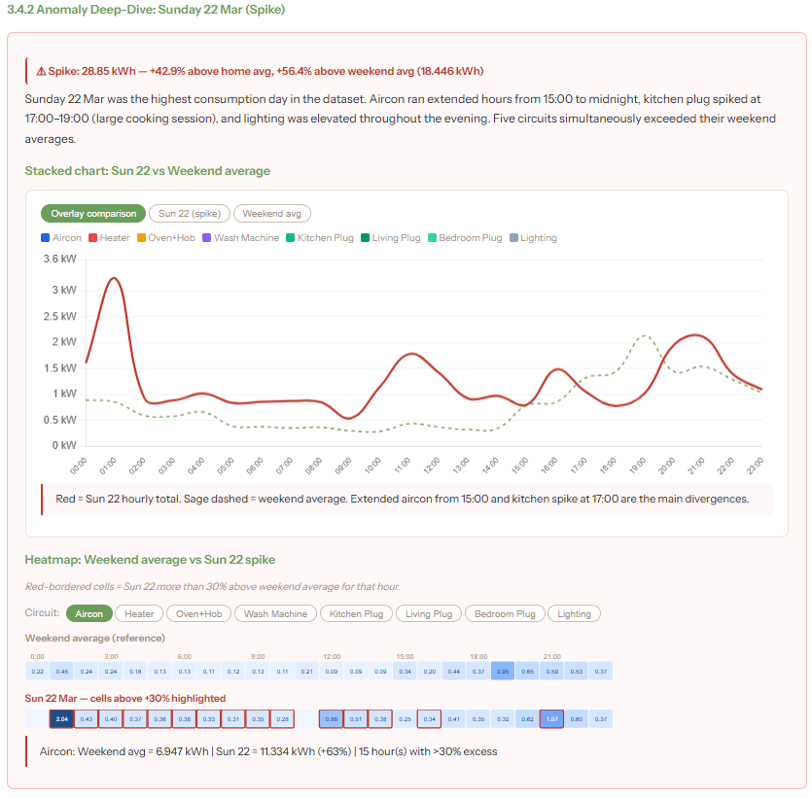
 |  | - 24hour behavrious analysis [for office/small scale only] | For per hour data, then that hour energy consumption is higher than average, it will look into which circuit cause the surge then immediately send an alert to management to check on the cause |  | 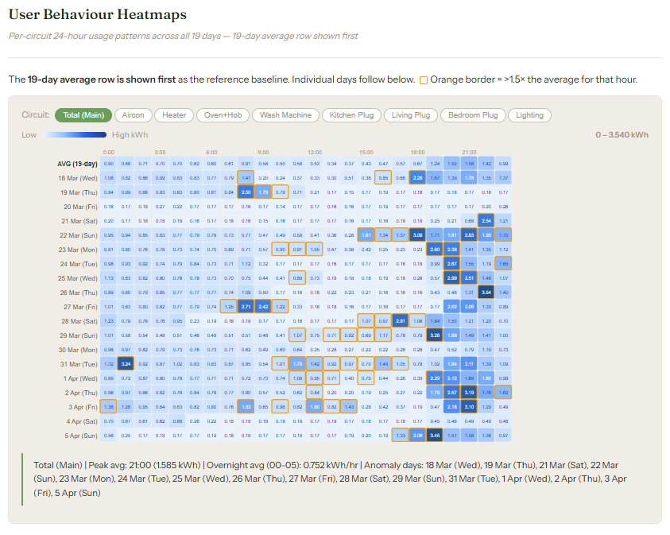  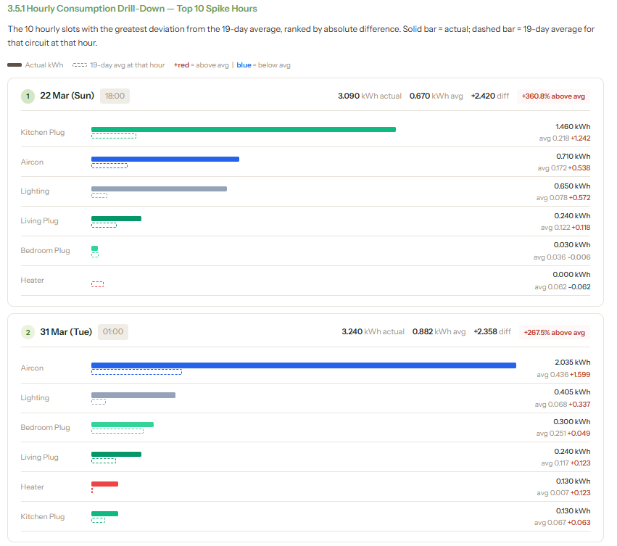
 |  | - Cost analysis | Put a price on the Kwh, let user have a dollar sense where is the monthly utility bills are spend on, in terms of which block, which floor, which appliance, which room is the highest etc. |  | 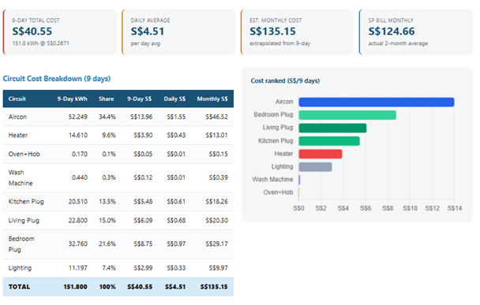
 |  | - Summary of findings | Key summary of the report |  | 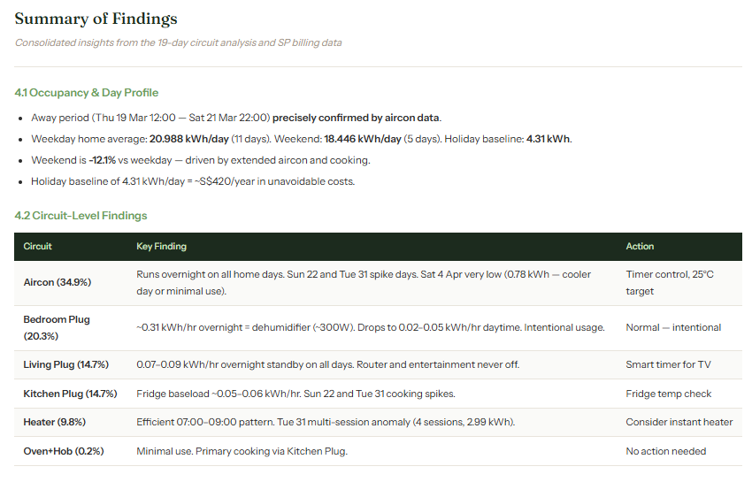
 |  | - AI Energy Saving Recommendation solution using VG existing solution, i.e. Aircon and Lighting optimization.  Move pie chart distribution here | Generate energy saving recommendation based on abnormally and findings  maintain a recommendation log that operations teams action. |  | 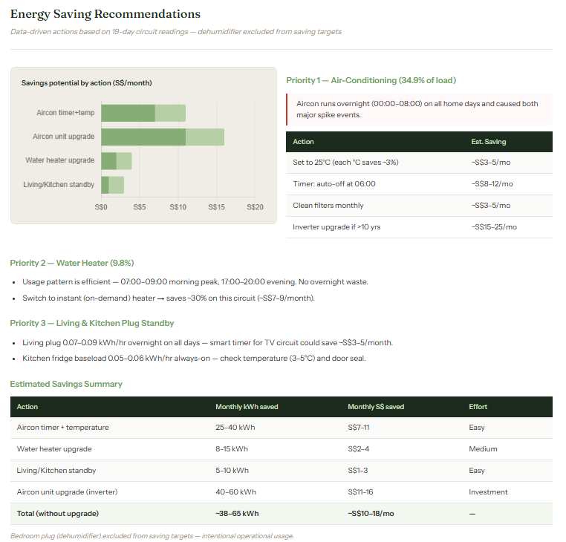
4 | Billing  [Original Temasek Poly Tender Requirement] | Tenants | Maintain tenant records and associate tenants.  Able to Import and export record.
 |  | Contracts | Maintain contract terms such as start/end dates and tenant allocation rules needed for utility billing and reporting.  Able to import and export contracts.  Able to add miscellaneous line items. | - Down to bed level, need to select down to bed level, bed level data use number of beds in the room to calculate average per bed consumption (already paid through Bok Seng)
 |  | Cost module | Build the cost module template here and after user create the contract, they can click on the cost module that is suitable based on their contract type,  allow to adjust utility rate here  creation of cost module can only be done by Tuya backend, don’t open up self create function | Room/Bed Allocation logic:  - Room Level (Pay-per-use Tenant)  Same as current one, use how much then pay how much  - Room Level (Fixed Utilities Tenant)  Usage threshold (kwh & m3) per room and per bed…  given/input by client (have to input in Contract)  if use 超过threshold, pay SGD 40 (default /and change manual change)  看看是不是可以 选择 用超过多少 就付超过的部分  - Bed Level (Pay-per-use Tenant)  床位计算 已经有  - Bed Level (Fixed Utilities Tenant)  - Bed Level (Pay-per-use & Fixed Utilities Tenant)  - Need to allow set benchmark consumption, below benchmark/excess is 0, above excess is a rate of $XX (Only for Fixed Utilities Tenants)  Kitchen utilities to be shared among occupied rooms for the respective level. 每层使用 的tanent平分
 |  | Bills | Generate, review, and export utility bills based on measured and virtual meter data.  Support downloadable billing-related reports and data export.  Support auto send bill to client email address for billing
5 | Data  [Original Temasek Poly Tender Requirement] | Devices | Monitor a master register of meters, sensors, and monitoring points with device details, equipment metadata, hierarchy location, appliance or load category, pictures, and linkage to schematics or detailed equipment screens.
 |  | Edge Gateway | Monitor gateway health, connectivity status, data flow, and communication quality between field devices and the platform. Detect offline gateways, jammed data transmission, and other edge communication issues.
 |  | Messages combine with Alarm | Centralize system notifications, alarm messages, data transmission issues, and other user-facing alerts for acknowledgement and follow-up.  Allow users to toggle between key messages types such as system messages, data messages, alarm/alert messages  Manage threshold alarms, anomaly alarms, communication failure alerts, stagnant-reading alerts, and hardware-related events. Support multiple threshold values, active periods, bulk rule application, alarm status tracking, and summary alarm views.
 |  | Logs | Record audit trails for  - User actions  - Configuration changes  - Device events, report generation, data export, and operational activities across the platform.  - System Changes/Updates Logs
6 | Project  [Original Temasek Poly Tender Requirement] | Roles | Define role-based access control so permissions can be assigned by organisation or functional module for administrators, operators, finance users, and viewers.  The user can view the following information in a table list.  - Role Name  - Role Description  - Users Assigned  - Created Time  - Action – View, Edit and Delete
 |  | Users | To create and manage users, the user can click on the “+ New User” button and fill up a form on that appears on the sidebar and assign them to organisations or assets and control their access through role-based permissions.  The user can view the following information in a table list.  - Name  - Email  - Mobile Number  - User Role  - Created Time  - Status – Active/Inactive  - Action – Edit, Reset Password and Delete
 |  | Space Hierarchy | Manage the site hierarchy and digital space model, includes (list is not exhaustive):  - Site  - Building  - Floor  - Area  - Zone  - Room  - Bed  - Roof  - Generator Room  - LV Room  - HT Room  - Electrical Riser  - ELV Riser  - Water Closet  - Pump Room  - Chiller Pump Room  Store site metadata for navigation, reporting, and benchmarking such as:  - Address  - GFA  - Description  - Building type  - Lumens
 |  | Alarms Rules | Support threshold configuration for each monitoring point.  Threshold alerts are triggered when values exceed predefined limits.  Multiple thresholds per monitoring point must be supported.  Active periods for thresholds must also be configurable.  Configure alarm thresholds for utilities and equipment by:  - Parameter  - Hierarchy level, and  - Time window  Support device-level rules, hourly, daily, and monthly thresholds, and applying the same rule to multiple rooms, floors, blocks, or projects.  Able to Arm, Disarm and Inhibits alarm. | Alarm Notification Configuration  - Email  - SMS  - Web notifications  Data Anomaly Alerts  The system shall detect abnormal data patterns.  These alerts may be triggered automatically based on analytics or AI modules.  Example deviation thresholds:  1% deviation  5% deviation  The Platform should detect data anomalies with machine learning or other Artificial Intelligence (AI) technology based on the utilities data collected.  Data anomaly detection refers to the sudden drastic change in the trending data at a specific time frame, such changes detected could imply possible hardware failure, leakages, or usage abuse of energy and water.  Alert after 24hrs anormal consumption analysis, realtime abnormal consumption alert how to integrate with sms, whatsapp, email etc  Critical alert {Call}  Non critical alert: sms/whatsapp/email  可以设置 重要的 可以 立即通知  不重要的 等到 设定的时间通知
 |  | Data Configuration | Configure utility logic including:  - Adding and Removing Physical and Virtual meters  - Appliance or load tagging  - Benchmarking parameters  - EUI and WEI setup  - Cost factors  - Other calculation settings used by dashboards and reports.  - Tariff  - Currency calculations  - Carbon emission factor  把这些 放一起方便， this by project  The system must support historical utility rate management. 有效期  All rate changes must be stored with version history.
 |  | Dashboard Configuration | Design and maintain dashboard layouts, widgets, chart types, default filters, ranking views, and time-series options for different users or project templates.
 |  | Schematic Configuration | Create and maintain editable:  - Electrical single-line diagrams  - Water piping schematics  - SCADA or BMS-style views, equipment links, graphical alarm indicators, and upstream/downstream flow relationships.
 |  | Bill Configuration | User can modify the bill layout template according to their preference.  Set their emailing service.  Billing Period Setting  Schedule Invoicing Settings | Allow users to key in key information such as company logo, address, payment information into the standard template  Based on project….each project have its own template…
 |  | Project Setting | Data Retention  - Raw Data Retention  - Aggregated Data Retention  - Audit Log Retention
7 | System  [Original Temasek Poly Tender Requirement] | Setting | General:  - Platform Name  - Platform Version  - Timezone  - Date Format  - Logo  - Login Background Image  - Language  Authentication:  - MFA  - OTP Delivery – Email/SMS  - Azure AD/SAML Integration by proejct  - Password Policy  - Session Timeout  Notification:  - Email Notification  - SMS Notification | Only Accessible to superadmin
 |  | Organizations | Manage organisation master’s for multi-company or multi-client deployment, including portfolio ownership, access segregation, and organisation-level settings includes basic information.
 |  | Product | Maintain product and module definitions, feature packaging, and entitlement settings used to enable the correct platform capabilities for each deployment. And also, the different compatible meters product.
 |  | Driver | Manage device communication drivers and protocol templates used by gateways and monitoring hardware so the platform can integrate with different meter or equipment models.
 |  | Integration | API Integration with Third Party Platform  The system must provide API for external billing software to retrieve the energy consumption data, such as Xero, accounting software for invoicing and billing requirement | API Integration with Xero
8 | Reports  [Original Temasek Poly Tender Requirement] |  | System Availability Report - provide the system uptime percentage, and other information required for the assessment of system availability.  Based on Platform - Uptime, downtime.  Example:  System cannot be accessed  Login fails / server down  API not responding | - System Availability Summary  - System Availability Calculation Illustration:  Nos. of day for the month = 30  Nos. of hours per day = 24  Required System Availability = 97%  Required System Availability in hours = 30 x 24 x 97% = 698.4hrs  - Downtime Log (Monthly Audit Log)  - Performance Against SLA  - Incident Summary  - Root Cause Analysis  - Corrective & Preventive Actions  - Declaration
 |  |  | Data Unavailability Report - provide the data loss duration for each Monitoring Point, stagnant readings and communication failures for the assessment of recovery time objectives. | Recovery Time Objectives (RTO) is defined as a measurement of the period when any of the Data Point for a Monitoring Point is unavailable in the Platform.  The maximum allowable RTO is 72-hour
 |  |  | Incident report | - Incident date and time  - Recovery action  - Recovery date and time  - Root cause analysis
 |  |  | Utilities Report | Generate Analysis tab full report for client to view over each month
 |  |  | PUB Water Balance Chart  Able to generate PUB Water Balance Chart for water consumption with the following breakdown categories:  - Cooling Towers  - Swimming Pool  - Canteen/F&B  - Water Features  - Fire Protection  - Toilets  - General washing/others  Only in graph….. |  | 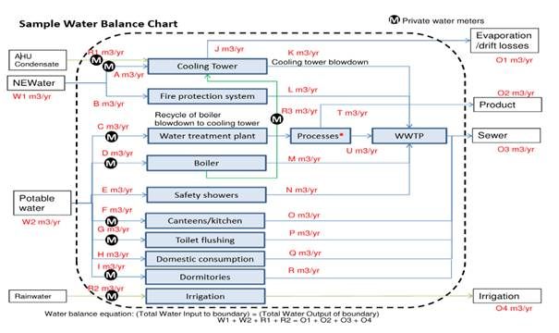
9 | Others  [Original Temasek Poly Tender Requirement] | Organization Drop down Menu | The superadmin can choose the different organisation that was configured in the system.  This will be the main filter. Only details or data related to that chosen organization will be shown.
 |  | Toggle Light/Dark Mode | This will toggle between light and dark mode.  Light Mode Colour Palette  Dark Mode Colour Palette
 |  | Notification Bell | To view new messages and faults and alarms
 |  | Account

